Join the competition for the best project in Renewable Energy and win 3.000€
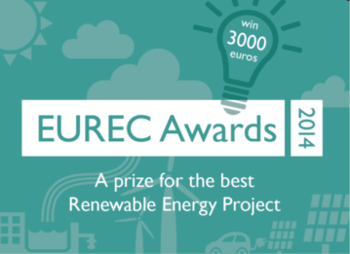
EUREC (The Association of European Renewable Energy Research Centres) will deliver three awards to the best students’ projects on Renewable Energy. The aim of these prestigious awards is to promote excellence in the study of Renewable Energy, to reward talent and to encourage Renewable Energy debate worldwide.
If you are in the last year of undergraduate studies or just graduated and interested in renewable energy, you are entitled to apply to the EUREC Awards competition.
The awards consist in one prize of 3.000€ to the best project and two prizes of 1.500€ to the second and third selected projects. The winners of the EUREC Award will receive them during the starting ceremony of the European Master in Renewable Energy in October in Brussels.
Think about the future, think Renewable and get a chance to win!
For more information and to apply, please visit our website: http://www.master.eurec.be/en/
